**The Muscle Health Research Centre at York University presents the**

**6th Annual Muscle Health Awareness Day (MHAD6)** 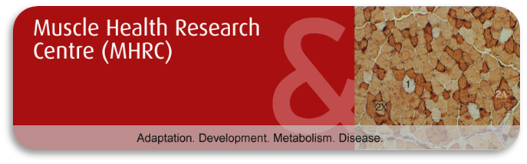

**Please fill out the form below. Once completed, save the file, and then email the completed form as an attachment to** [**mhrc@yorku.ca**](mailto:mhrc@yorku.ca) **to register for and/or submit an abstract for MHAD6. You will receive an email confirmation from the MHRC Centre Coordinator confirming your successful registration and/or abstract submission.**

**Please fill out all of the following fields contained within this box (required):**

**Last Name:** Click here to enter text. **First Name:** Click here to enter text.

**University:** Click here to enter text. **Supervisor:** Click here to enter text.

**Current Degree Program (click the appropriate box):**

**Undergraduate  Master’s Degree  Doctoral Degree**

**Post-doctoral fellow  Other  (please specify)** Click here to enter text.

**Email Address:** Click here to enter text.

**Will you be attending breakfast and/or lunch (click appropriate boxes):**

**Breakfast Yes  No**

**Lunch Yes  No**

**Are you submitting an abstract? Yes  No**

**Please fill out the fields below ONLY IF YOU ARE SUBMITTING AN ABSTRACT FOR A POSTER PRESENTATION. The information you include below will be included in the official proceedings of MHAD6.**

**Abstract Title:** Click here to enter text.

**Authors:** Click here to enter text.

**Author Affiliations:** Click here to enter text.

**Abstract text (no figures are permitted):** Click here to enter text.